
Azerbaijan State Oil & Industry University
BA Programs
Data analytics
Introduction to Data Analytics
Report

Student: Fakhri Safarov
Title: SILENTMEET AI
Teacher: Malik Mammadli

Baku-2025

Contents
1. Introduction 2
2. Objective 2
3. SilentMeet Platform Overview 2
3.1 Core Functional Components 2
3.2 Silent Speech and Real-Time Translation Features 2
3.3 Accessibility and User Support System 2
4. Data Analysis and User Insights 3
4.1 Demand for Silent and Multilingual Communication 3
4.2 Barriers to Adoption of Digital Communication Tools 3
4.3 Desired Features in Communication Platforms 3
4.4 Demographic Usage Trends 3
5. Competitive Analysis 3
5.1Comparison with Existing Communication Platforms 3
6. Conclusion 3

1. Introduction
The lack of effective communication tools in noise-sensitive environments (libraries, hospitals, offices, public transport) and for people with hearing or speech impairments is a significant problem in modern society. People need silent, fast, and multilingual communication solutions. Existing translation and voice assistant applications do not fully meet this need. SilentMeet is an innovative mobile platform designed to fill this gap by combining AI-based silent speech processing and real-time translation features. This report presents the design principles, data analysis, market research, and project outcomes of the SilentMeet platform.

2. Objective
The main objective of this project is to design and analyze a personalized silent communication platform based on user needs and market dynamics. The project aims to:
- Identify communication challenges in quiet environments and for people with additional needs
- Anlyze user interest and barriers to adopting digital communication tools
- Determine the most desired features in communication platforms
- Position SilentMeet competitively within the existing digital communication market

3. SilentMeet Platform Overview
SilentMeet is an integrated mobile platform that combines silent speech conversion, real-time multilingual translation, text-to-speech synthesis, and AI-based sign language recognition. The platform enables users to communicate quickly and effectively without the need for audible speech.
Core platform features (Image 1).
User interface: silent speech input and real-time translation screen (Image 1).
Language selection and accessibility settings (Image 1).
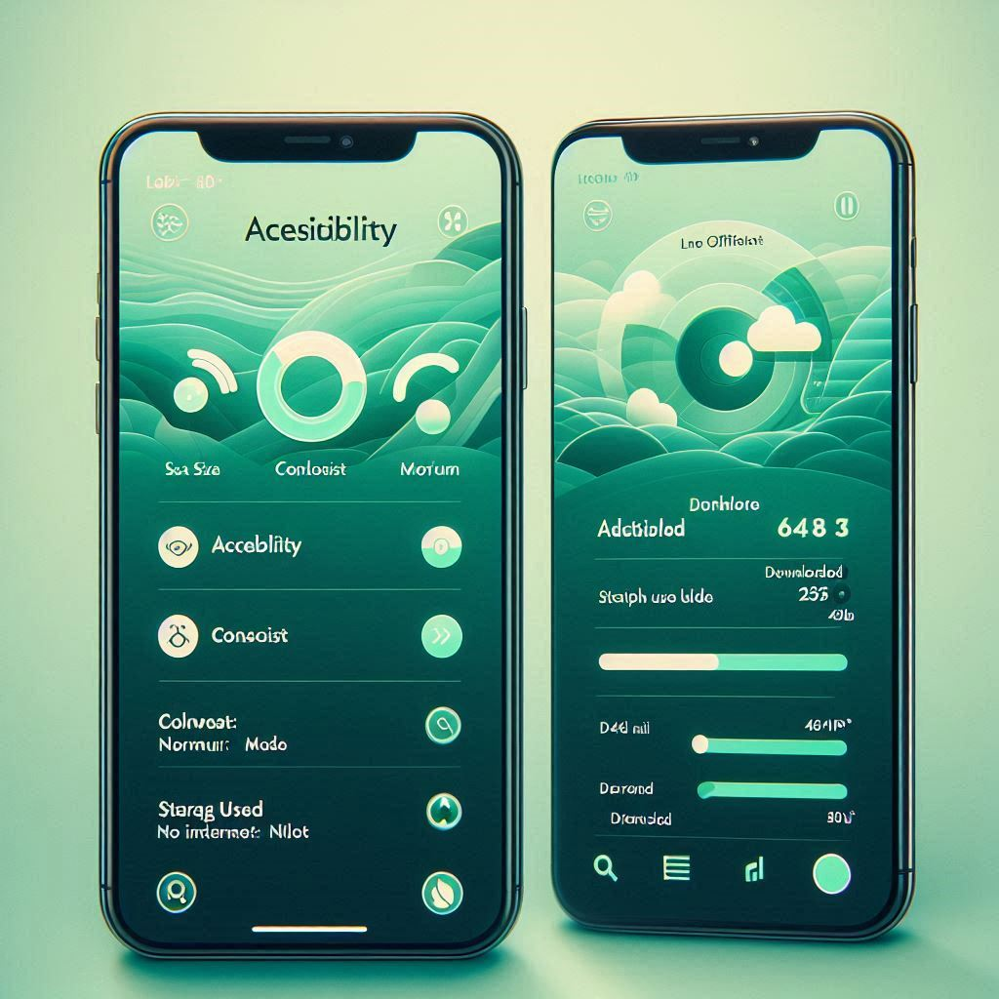
Image 1: Conceptual interface of the silent communication platform
The system is built around several core components that work together to deliver a seamless user experience.
3.1 Core Functional Components
The SilentMeet platform includes the following core functional components:
- AI-based personalization: Translation suggestions tailored to the user's speech pace, language style, and communication context
- Silent speech processing: High-accuracy conversion of whispers and low-volume speech to text
- Real-time multilingual translation: Instant written and spoken translation across 30+ languages
- Offline mode: Basic language packages that work without an internet connection
3.2 Silent Speech and Real-Time Translation Features
Silent speech technology is the foundation of the platform. When the user speaks in a whisper, the AI model converts the audio to text and translates it in real-time to the selected language. This feature is particularly useful in quiet environments such as libraries, hospitals, or open offices.
3.3 Accessibility and User Support System
SilentMeet is also adapted for users with hearing and speech impairments. The platform offers AI-based sign language recognition and conversion to text/translation. Additionally, users can customize interface settings (font size, contrast, speech rate) according to their needs.

4. Data Analysis and User Insights
This section presents the analysis of secondary data collected from academic research and public surveys related to communication tool usage.
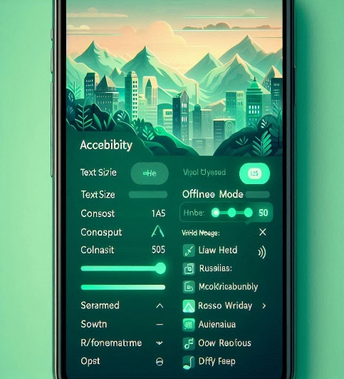
Image 2: Communication application development process
4.1 Demand for Silent and Multilingual Communication
Survey data indicates that a significant portion of participants (approximately 65%) need communication tools in quiet environments. Over 70% of international travelers report using real-time translation tools.
4.2 Barriers to Adoption of Digital Communication Tools
Despite high interest, several barriers prevent widespread adoption. The most commonly reported issues are: privacy and data security concerns (45%), lack of offline functionality (38%), and complex user interfaces (32%).
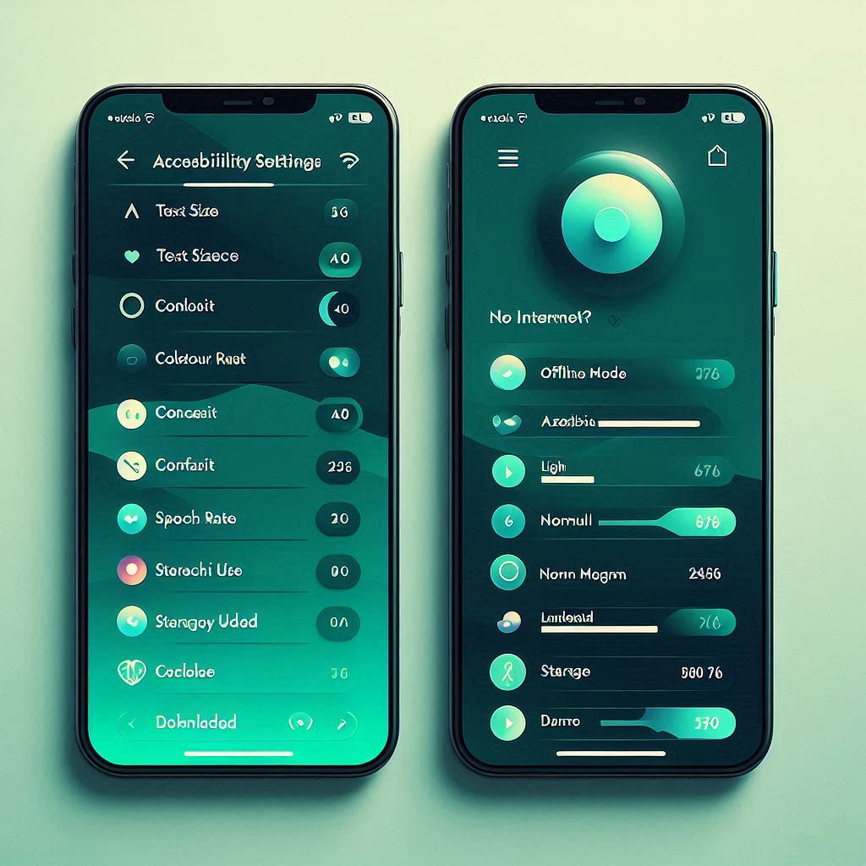
Image 3: Barriers to adoption of digital communication tools
4.3 Desired Features in Communication Platforms
Users show the strongest preference for real-time translation (85%), followed by offline functionality (72%) and silent input mode (68%). These findings directly support SilentMeet's design priorities.
4.4 Demographic Usage Trends
Usage trends indicate higher adoption rates among students and international workers. Additionally, demand for offline functionality is more pronounced among the 35–50 age group.

5. Competitive Analysis
The communication and translation app market includes several established platforms. SilentMeet differentiates itself by integrating multiple high-demand features into a single platform. Table 1 below compares key features offered by SilentMeet and leading communication platforms.
Feature | SilentMeet | Google Translate | Microsoft Translator | AVA (Accessibility)
Silent speech mode | ✔ | ❌ | ❌ | ❌
Real-time AI translation | ✔ | ✔ | ✔ | ❌
Offline operation | ✔ | Limited | Limited | ✔
Sign language recognition | ✔ | ❌ | ❌ | ✔
Personalized settings | ✔ | ❌ | ❌ | ✔
Table 1: Feature comparison of digital communication platforms
5.1 Comparison with Existing Communication Platforms
Compared to competitors, SilentMeet offers a unified solution that combines AI personalization, silent communication, offline functionality, and accessibility features. This integrated approach aligns well with user expectations and strengthens the platform's competitive position.

6. Conclusion
The project demonstrates strong market demand for personalized silent communication solutions supported by data-driven insights. SilentMeet addresses key user needs while acknowledging existing challenges related to privacy, offline functionality, and usability. With further development and primary user testing, the platform has the potential to become a valuable and competitive communication solution.
Recommendations for future development:
- Expand language support to 50+ languages
- Develop corporate partnership programs
- Launch dedicated iOS and Android applications
- Implement end-to-end encryption for enhanced privacy

References:
- World Health Organization – Assistive Technology Guidelines, 2023
- "Real-time speech processing in noisy environments" – Journal of AI Research, 2024
- "User adoption barriers of digital communication tools" – International Journal of Human-Computer Interaction, 2023
- "Multilingual translation systems: user expectations vs reality" – Proceedings of ACL, 2024
- Statista – Mobile communication app usage demographics, 2024
- Gartner – Market Analysis: Communication and Translation Technology, 2024
References:
https://ourworldindata.org/grapher/hearing-loss-by-age-group?tab=line&time=1990..2021
https://ourworldindata.org/grapher/hearing-loss-by-age-group?tab=table&time=2021
https://ourworldindata.org/grapher/hearing-loss-by-age-group?time=2021
FROM ME .

